**1.** what model should you select

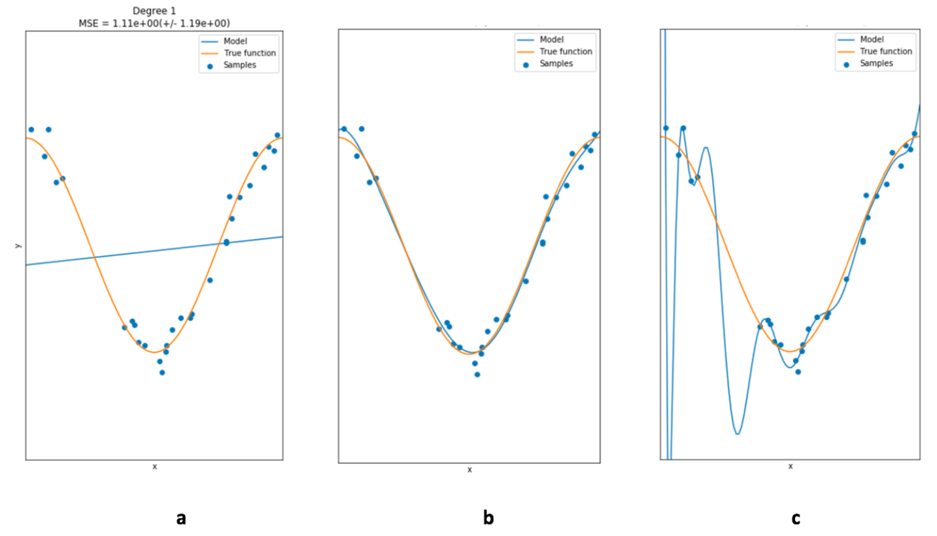

* c
* b
* a